System Call Lab

# CONCLUSIONS

* I was successful on the first part of the lab
* I was successful on the second part of the lab
* Problems
  + I forgot to change the function signature in *syscalls.h* from (void) to (char*, char*)
* Screenshots

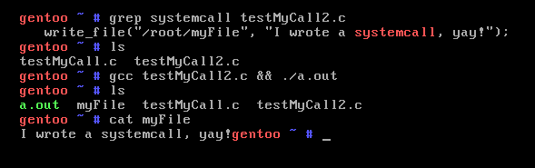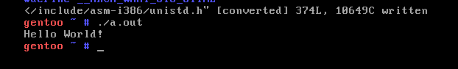

Figure - write_file proof

Figure - Helloworld proof